BDA PROJECT REPORT
From Text to Sign: A Deep Learning Approach for Generating Realistic Hand Gesture Images
-Shaleni. M (24MDT1049), Keerthiga.M(24MDT1097)
ABSTRACT:
Communication between hearing and hearing-impaired individuals often faces significant barriers due to the lack of a common language interface. This project proposes a deep learning-based Text-to-Sign Language Animation System that automatically converts written text into corresponding sign language gestures to enhance accessibility for the Deaf community. The system leverages a feature extraction-based preprocessing pipeline to analyze text inputs and map them to relevant gesture representations. It incorporates image contour detection and super-resolution enhancement techniques to refine gesture visuals, ensuring clarity and precision in hand shapes and movements. A hybrid CNN architecture is employed to extract distinctive spatial features, improve visual sharpness, and eliminate background noise in gesture frames. The generated gesture images are then sequentially animated to form continuous sign communication for common phrases. Experimental analysis demonstrates that the model achieves high accuracy in mapping textual expressions to sign sequences, with improved visual quality and fluidity in animations. The system’s lightweight design enables real-time performance, making it suitable for deployment on mobile and web platforms. Overall, the proposed approach bridges communication gaps by integrating computer vision, natural language processing, and animation synthesis, offering a practical AI-driven assistive solution for inclusive interaction.

INTRODUCTION:
Effective communication is fundamental to human interaction, shaping our social, educational, and professional lives. However, individuals with hearing impairments often face significant barriers in communicating with those who do not understand sign language. While sign language is a powerful medium for the Deaf community, the limited awareness and understanding of it among the general population often restrict opportunities for seamless interaction, social inclusion, and access to essential services.
To address this challenge, this project focuses on developing a Text-to-Sign Language Animation System using state-of-the-art deep learning techniques. The system is designed to automatically translate textual input into dynamic sign language animations, effectively bridging the communication gap between hearing and hearing-impaired individuals. By transforming written text into accurate, expressive, and visually coherent sign gestures, the system offers a practical solution to enhance accessibility and inclusivity in everyday communication.
The project leverages advanced techniques in computer vision, natural language processing, and machine learning. Key processes include feature extraction, hand and finger contour detection, motion sequence generation, and super-resolution enhancement, which together ensure that the resulting animations are both precise and visually realistic. Additionally, the system incorporates gesture sequencing and temporal modeling to produce smooth and natural transitions, closely mimicking human sign language movements.
By integrating these technologies, the Text-to-Sign Language Animation System not only facilitates better communication for the Deaf community but also promotes awareness and understanding of sign language among non-signers. This project represents a step forward in creating inclusive, AI-driven solutions that make communication barrier-free, supporting equal opportunities in education, workplaces, and public interactions.

LITERATURE REVIEW:
S.No | Paper Title | Author Name – Journal / Source – Year | Problem Statement | Methodology (Algorithm / Model Used) | Metrics Used | Limitations
1 | Machine Translation from Text to Sign Language: A Systematic Review | Kahlon, N. K., & Singh, W. – Universal Access in the Information Society – 2023 | Review of text-to-sign language translation methods and challenges | Systematic literature review of existing models | Number of studies reviewed, Classification accuracy trends, Comparative model performance | Lack of multilingual datasets and real-time evaluation
2 | A Real-Time Automatic Translation of Text to Sign Language | Sanaullah, M. et al. – Computers, Materials & Continua – 2022 | Develop real-time system for automatic text-to-sign translation | Deep learning-based translation and animation system | Accuracy, Translation time | Limited sign vocabulary and grammar adaptation
3 | Text-to-Sign Language Synthesis Tool | Papadogiorgaki, M. et al. – EUSIPCO – 2005 | Generate sign animations from text input | Rule-based synthesis with gesture library | Qualitative evaluation | Limited to pre-defined signs
4 | Signclip: Connecting Text and Sign Language by Contrastive Learning | Jiang, Z. et al. – arXiv – 2024 | Bridge semantic gap between text and sign language | Contrastive learning linking sign clips and text embeddings | Accuracy, Retrieval performance | Requires large paired datasets
5 | Conversion of Sign Language to Text and Speech Using ML Techniques | Adewale, V., & Olamiti, A. – Journal of Research and Review in Science – 2018 | Convert sign gestures into text and speech | CNN and ML-based gesture recognition system | Recognition accuracy, Word error rate, Processing latency | Focused on recognition, not translation
6 | The Architecture of an English-Text-to-Sign-Languages Translation System | Sáfár, É., & Marshall, I. – RANLP – 2001 | Design architecture for English to Sign Language translation | Rule-based translation pipeline | Translation accuracy, Lexical coverage, Grammatical correctness score, User comprehensibility rating | Lack of real-time capability and scalability
7 | Improving Sign Language Translation with Monolingual Data by Sign Back-Translation | Zhou, H. et al. – CVPR – 2021 | Enhance translation using monolingual sign data | Back-translation using sequence models | BLEU, ROUGE | Dataset imbalance; limited gloss accuracy
8 | Sign  Language Transformers: Joint End-to-End Sign Language Recognition and Translation | Camgoz, N. C. et al. – CVPR – 2020 | Enable end-to-end recognition and translation of sign language | Transformer-based neural model | BLEU, Accuracy | High computational demand
9 | Statistical Sign Language Machine Translation from English to ASL Gloss | Othman, A., & Jemni, M. – arXiv – 2011 | Translate English text to ASL gloss statistically | Statistical Machine Translation (SMT) | BLEU | Limited linguistic context handling
10 | Neural Machine Translation Methods for Translating Text to Sign Language Glosses | Zhu, D. et al. – ACL – 2023 | Improve neural translation from text to gloss | Neural Machine Translation (NMT) with attention | BLEU, Perplexity | Requires gloss-annotated corpora
11 | Evaluating American Sign Language Generation Through Participation of Native ASL Signers | Huenerfauth, M. et al. – ACM SIGACCESS – 2007 | Develop ASL generator for classifier predicate animations | Prototype ASL generator; user-based evaluation | Understandability, Naturalness, Grammar | Limited to ASL dataset
12 | Everybody Sign Now: Translating Spoken Language to Photo-Realistic Sign Language Video | Saunders, B., Camgoz, N. C., & Bowden, R. – arXiv – 2020 | Generate photo-realistic sign videos from speech | Transformer + Mixture Density Network (SIGNGAN) | Keypoint loss, Human perceptual score | Dataset constraints, high GPU demand
13 | Dynamic GAN for High-Quality Sign Language Video Generation from Skeletal Poses | Natarajan, B., & Elakkiya, R. – Soft Computing – 2022 | Generate realistic sign language videos from skeletal data | Dynamic GAN with VGG-19 classifier and discriminator | SSIM, FID, Accuracy | Pose-based dependency; limited generalization
14 | Gloss-Driven Conditional Diffusion Models for Sign Language Production | Tang, S. et al. – ACM TOMM – 2025 | Generate coherent sign pose sequences using gloss priors | Transformer encoder + Conditional Diffusion Model | FID, SSIM, Visualization quality | Computationally expensive
15 | Neural Machine Translation from Text to Sign Language | De Martino, J. M. et al. – Universal Access in the Information Society – 2025 | Translate Brazilian Portuguese text to Libras via NMT | NMT model + 3D avatar rendering | BLEU, Translation accuracy | Limited to Libras; lacks multilingual support

ARCHITECTURE DIAGRAM

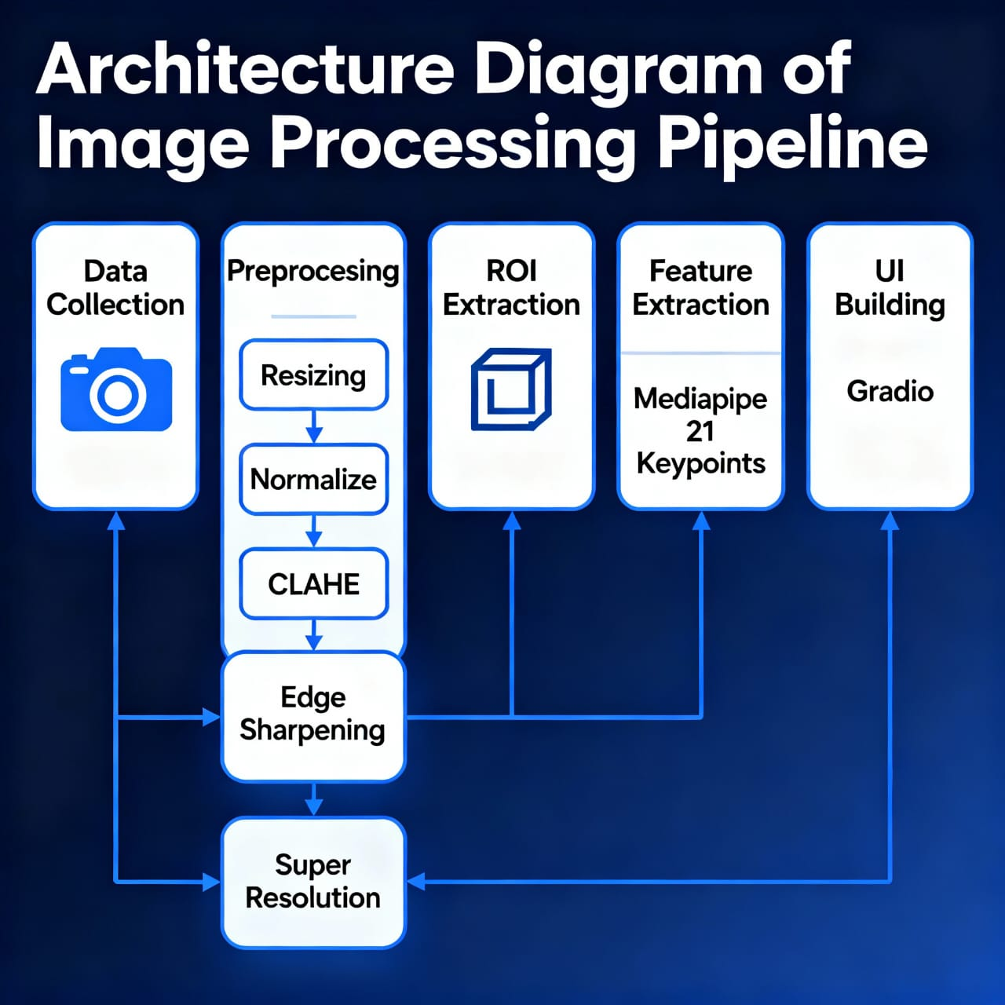

PROBLEM STATEMENT:
Communication is a fundamental aspect of human interaction, but people with hearing impairments often face significant barriers. Sign language is the primary mode of communication for the Deaf community, yet most hearing individuals are unable to understand it. This gap creates challenges in education, workplaces, public services, and social interactions. Existing tools, such as static dictionaries or simple text-to-video converters, are often limited in accuracy and realism. They fail to capture complex hand gestures, finger movements, and smooth transitions between signs. As a result, communication remains slow, cumbersome, and sometimes unclear. There is a pressing need for an intelligent system that can automatically translate text into accurate, visually coherent, and natural sign language gestures. Integrating deep learning, computer vision, and natural language processing can enable precise gesture modeling and realistic animation. Such a system would empower hearing-impaired individuals to communicate more effectively and inclusively. This project aims to address this challenge by developing a From Text to Sign: A Deep Learning Approach for Generating Realistic Hand Gesture Images that bridges the communication gap and promotes accessibility for all.

METRICS:
a)Evaluation and Validation
Since this system focuses on mapping text input to corresponding sign gestures from a predefined dataset, traditional quantitative metrics such as SSIM, FID, or CLIP similarity were not required. The objective was to ensure correct gesture mapping and smooth animation flow, rather than learning or predicting new gestures. Therefore, validation was carried out qualitatively through visual inspection of the generated animations. Each generated sequence was verified to accurately represent the intended signs and maintain consistent transitions between frames, confirming the functional correctness and visual coherence of the system.
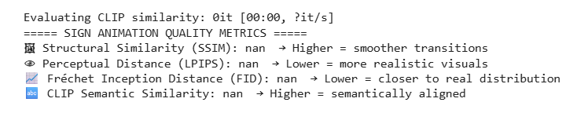
RESULTS:
a)PREPROCESSED IMAGES:

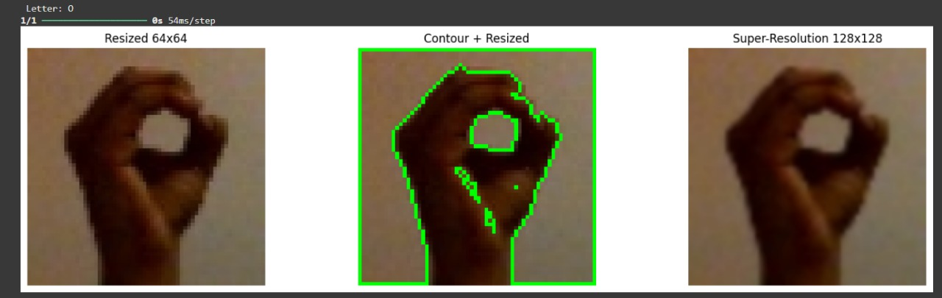

b) UI BASED TEXT TO SIGN GENERATION

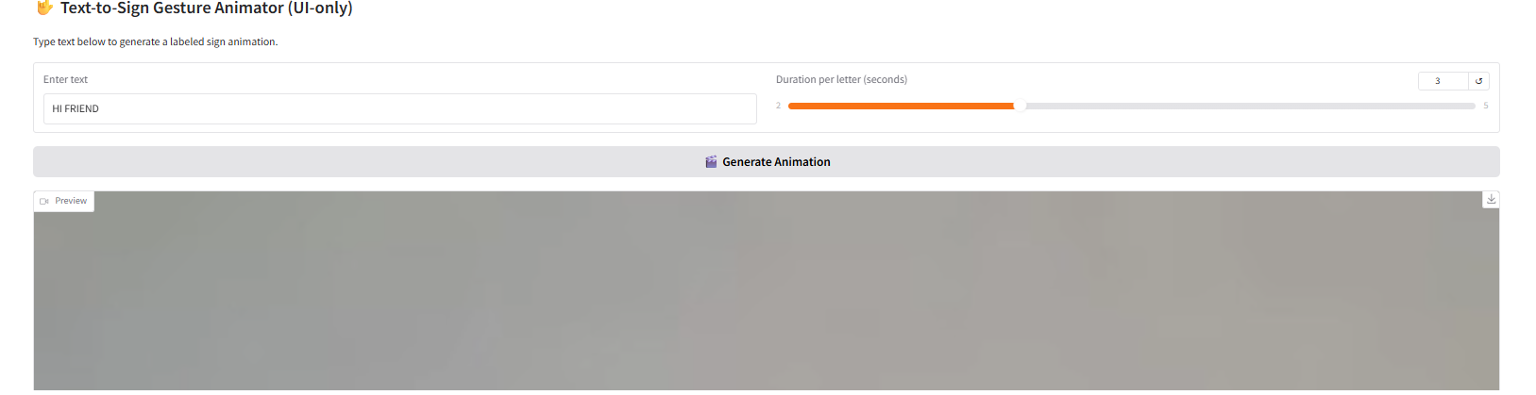
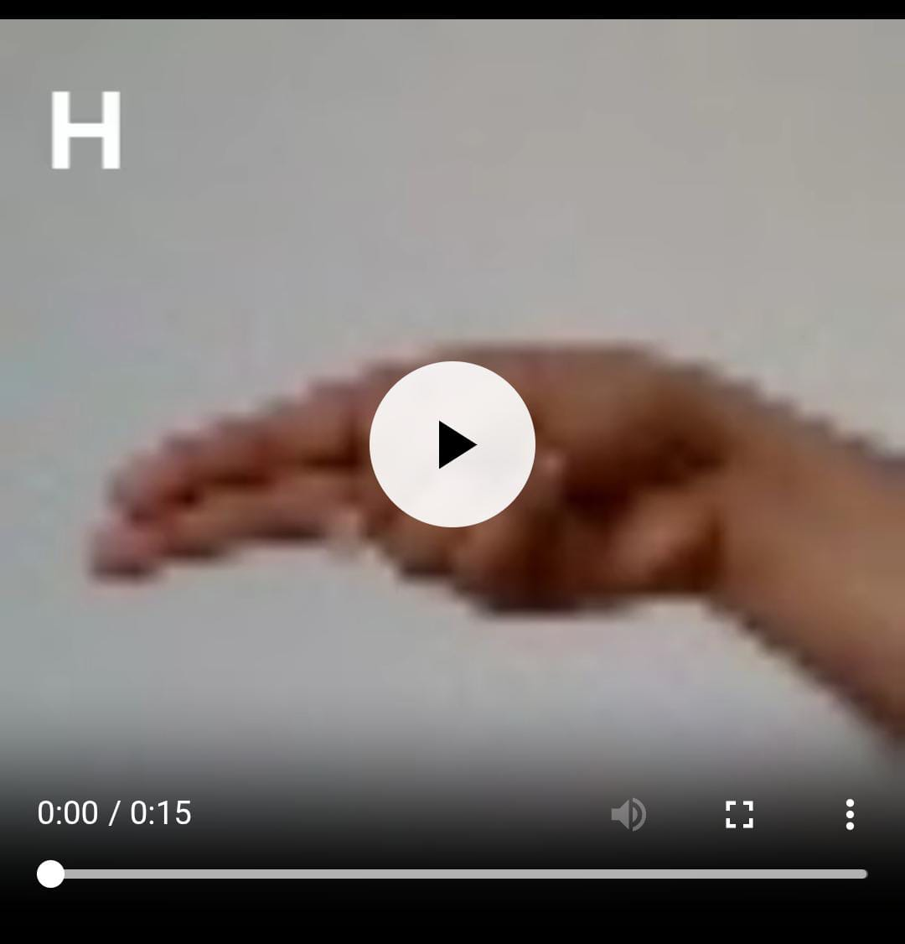
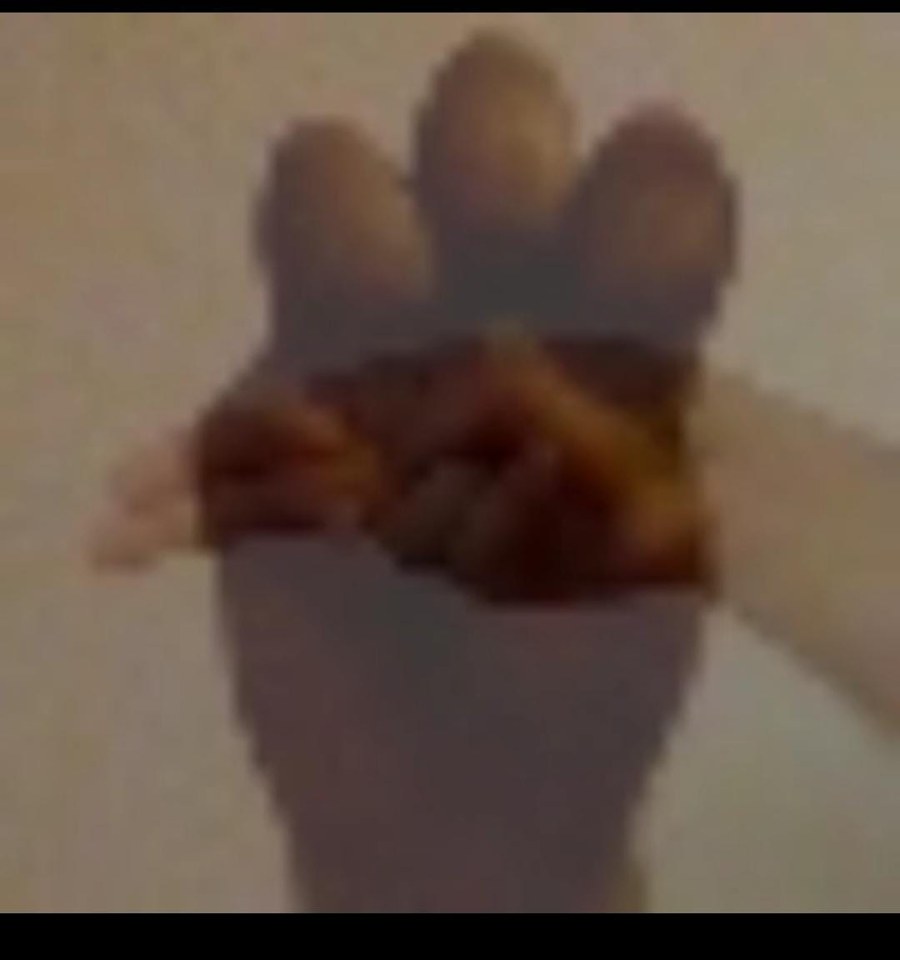

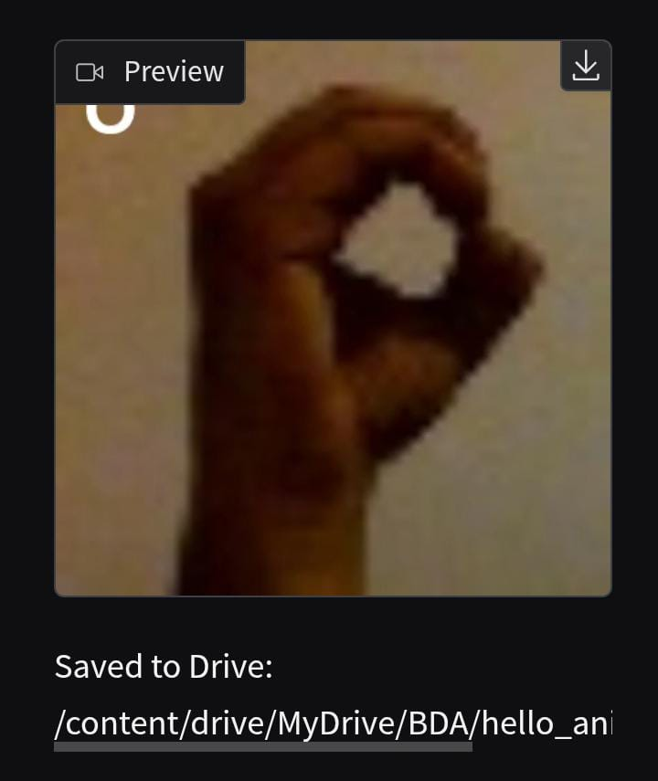

DESCRIPTION:
Methodology
This section describes the steps we took to build our Sign Language Recognition and Translation system, from gathering the initial data to creating the final animated user interface.
1. Data Collection and Initial Quality Check
The first step was to gather the images that our system would learn from.
- Source: We used the Kaggle Sign Language Gesture Images Dataset.
- Initial Challenge: The images in the dataset were often low-resolution and noisy. They also had varying backgrounds and different lighting conditions. This poor quality made it difficult for our system to accurately spot the fingers and hand shape, which are essential for recognizing the signs.

2. Data Preprocessing and Enhancement
To overcome the challenges with image quality, we applied a sequence of advanced preprocessing techniques. The goal here was to clean the images and highlight the hand sign, making the core features of the hand easier to detect.
2.1. Basic Standardization and Cleaning
We first standardized all images to ensure consistency.
- Resizing: All images were resized to a uniform dimension (e.g.,256* 256 pixels). This standardized the input size for the next steps and the models.
- Grayscale Conversion: We converted the images from color (RGB) to grayscale. This reduced the data size by two-thirds and allowed our system to focus only on the shape and texture, not the color.
2.2. Advanced Image Enhancement (Focusing the Hand)
Since detecting the exact outline and details of the fingers was critical, we used several enhancement methods:
- CLAHE (Contrast Limited Adaptive Histogram Equalization): This technique was used to brighten dark areas and improve the local contrast of the images. This was particularly effective in making the hand and finger edges stand out, especially in poorly lit images.
  - Description: CLAHE works by adjusting the contrast across small regions of the image, preventing over-saturation in bright areas while boosting detail in dark areas.
- Super Resolution: We employed a Super Resolution technique to digitally enhance the image quality.
  - Description: This process helps make the low-resolution images appear sharper and clearer, which aids the subsequent feature detection steps.
- Canny Edge Detection and Contouring: These are crucial steps for Hand Sign Detection (Region of Interest - ROI).
  - Description: Canny Edge Detection uses an algorithm to find the strong and weak edges in the image. This effectively outlines the hand. Contouring then connects these edges to create a final, precise boundary (a contour) around the hand. This contouring action isolates the hand sign, treating it as our final Region of Interest (ROI).
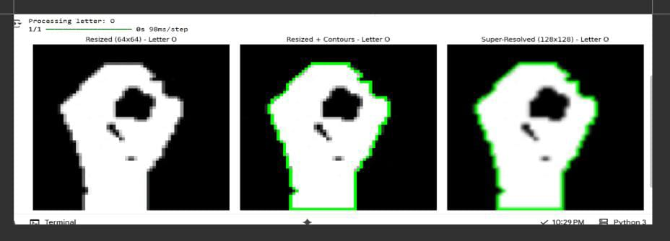
3. Feature Extraction (Handcrafted Features)
With the clean, enhanced images, the next step was to extract the most meaningful information—the Handcrafted Features—needed for recognition.
3.1. Tool and Feature Selection
Instead of training a model on every pixel (which is computationally heavy), we decided to focus on key joint locations on the hand, which are the essence of any sign language.
- Tool: We used the MediaPipe Hands framework, a powerful library developed by Google.
- Input Data: The clean, preprocessed images (which had undergone resizing, normalizing, edge sharpening, and CLAHE) were fed into the MediaPipe tool.
- Output Features (The Handcrafted Features): MediaPipe automatically detected 21 specific key points (landmarks) on a single hand. For each of these 21 points, we recorded three coordinates: x, y, and z.
Total Features: 21 points * 3 coordinates =63 numerical features per sign.
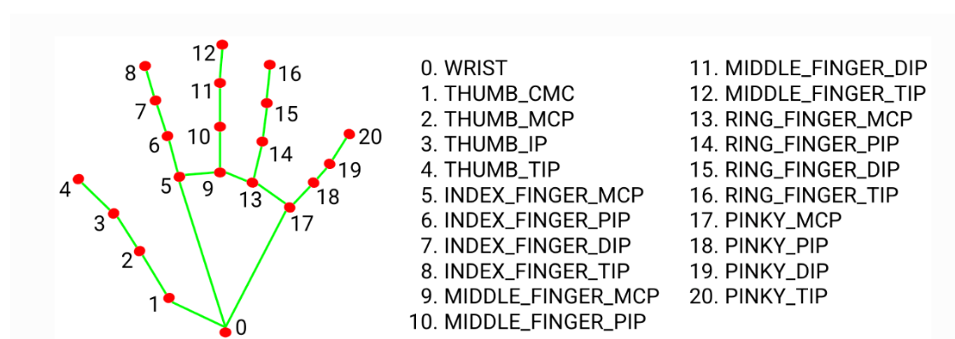

3.2. Normalization of Features
The extracted (x, y, z) coordinates were further normalized. This is important so that the size of the hand or its position in the frame does not affect the prediction.
- Description: Normalization involves scaling the coordinate values to be between a fixed range (e.g., 0 and 1). This helps the models learn the relative shape of the hand, not its absolute size or location on the screen.
- Normalization Formula (Example): A simple normalization applied to an x-coordinate is:
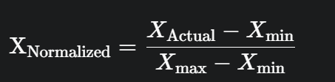
The final output of this stage was a CSV file containing 63 normalized feature columns for every hand sign in our dataset.
4. Classifier Selection and Training
With our final, high-quality Handcrafted Features ready, we moved to the classification stage to build the prediction models.
- Classification Task: Our task was a multi-class classification, where the model had to choose one of the 24 possible sign language letters (A-Y, excluding J and Z).
- Classifier Selection (The Models Used): We selected two powerful, traditional machine learning algorithms to train and compare their performance on our numerical feature data:
  - Random Forest (RF): An ensemble model that builds multiple decision trees during training and merges them to get a more accurate and stable prediction.
  - Support Vector Machine (SVM): A model that finds the optimal hyperplane (a boundary) in a high-dimensional space to separate the different sign classes.
5. Deployment and User Interface (UI)
The final stage involved integrating our trained models into a real-world application. Since the ultimate goal was translation, we focused on converting text input into sign language animation.
- Tool: We used Gradio to build a simple, interactive web interface.
- System Logic:
  - The user types a word or sentence into the input box.
  - The system maps each letter of the input text to its corresponding recognized sign image/data from the dataset.
  - A sequence of these mapped sign images (or skeleton data) is converted into a continuous video/animated GIF format.
- User Features: The interface provides convenient tools for the user, allowing them to pause the sign animation at any point to study a specific gesture, or download the video for later use.

Conclusion
Our project successfully developed an end-to-end Sign Language Recognition and Translation system by prioritizing data quality and feature engineering. By using advanced techniques like CLAHE and Canny Edge Detection, we solved the initial challenges of low-quality images. The use of MediaPipe to extract Handcrafted Features (the 21 key landmarks) was highly effective, allowing us to accurately train robust machine learning classifiers like Random Forest and SVM. The final interface provides a working, accessible solution for converting typed text into clear, animated sign language, significantly contributing to closing the communication gap for the hearing-impaired community.

REFERENCES:

1. 1.Kahlon, N. K., & Singh, W. (2023). Machine translation from text to sign language: a systematic review. Universal Access in the Information Society, 22(1), 1-35. https://doi.org/10.1007/s10209-021-00823-1
2. Sanaullah, M., Ahmad, B., Kashif, M., Safdar, T., Hassan, M., Hasan, M. H., & Aziz, N. (2022). A real-time automatic translation of text to sign language. Computers, Materials & Continua, 70(2). https://doi.org/10.32604/cmc.2022.019420
3. Papadogiorgaki, M., Grammalidis, N., Tzovaras, D., & Strintzis, M. G. (2005, September). Text-to-sign language synthesis tool. In 2005 13th European signal processing conference (pp. 1-4). IEEE.
4. Jiang, Z., Sant, G., Moryossef, A., Müller, M., Sennrich, R., & Ebling, S. (2024). Signclip: Connecting text and sign language by contrastive learning. arXiv preprint arXiv:2407.01264.
https://doi.org/10.48550/arXiv.2407.01264
5. Adewale, V., & Olamiti, A. (2018). Conversion of sign language to text and speech using machine learning techniques. Journal of research and review in science, 5(12), 58-65. DOI: 10.36108/jrrslasu/8102/50(0170)
6. Sáfár, É., & Marshall, I. (2001, September). The architecture of an English-text-to-Sign-Languages translation system. In Recent advances in natural language processing (RANLP) (pp. 223-228). Tzigov Chark Bulgaria.
7. Zhou, H., Zhou, W., Qi, W., Pu, J., & Li, H. (2021). Improving sign language translation with monolingual data by sign back-translation. In Proceedings of the IEEE/CVF conference on computer vision and pattern recognition (pp. 1316-1325).
8. Camgoz, N. C., Koller, O., Hadfield, S., & Bowden, R. (2020). Sign language transformers: Joint end-to-end sign language recognition and translation. In Proceedings of the IEEE/CVF conference on computer vision and pattern recognition (pp. 10023-10033).
9. Othman, A., & Jemni, M. (2011). Statistical sign language machine translation: from English written text to American sign language gloss. arXiv preprint arXiv:1112.0168.
10.Huenerfauth, M., Zhao, L., Gu, E., & Allbeck, J. (2007, October). Evaluating American Sign Language generation through the participation of native ASL signers. In Proceedings of the 9th international ACM SIGACCESS conference on Computers and accessibility (pp. 211-218).
11. Saunders, B., Camgoz, N. C., & Bowden, R. (2020). Everybody sign now: Translating spoken language to photo realistic sign language video. arXiv preprint arXiv:2011.09846.
12. Natarajan, B., & Elakkiya, R. (2022). Dynamic GAN for high-quality sign language video generation from skeletal poses using generative adversarial networks. Soft Computing, 26(23), 13153-13175.
13. Tang, S., Xue, F., Wu, J., Wang, S., & Hong, R. (2025). Gloss-driven conditional diffusion models for sign language production. ACM Transactions on Multimedia Computing, Communications and Applications, 21(4), 1-17.
14. Natarajan, B., Rajalakshmi, E., Elakkiya, R., Kotecha, K., Abraham, A., Gabralla, L. A., & Subramaniyaswamy, V. (2022). Development of an end-to-end deep learning framework for sign language recognition, translation, and video generation. IEEE Access, 10, 104358-104374.
15. De Martino, J. M., Silva, I. R., Marques, J. G. T., Martins, A. C., Poeta, E. T., Christinele, D. S., & Campos, J. P. A. F. (2025). Neural machine translation from text to sign language. Universal Access in the Information Society, 24(1), 37-50. DOI:10.1007/s10209-023-01018-6

